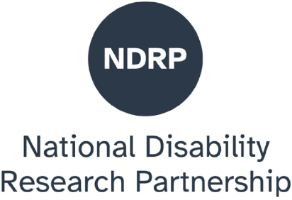

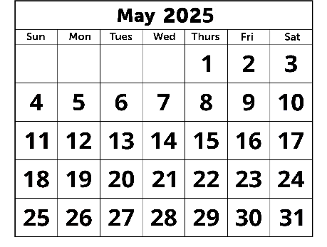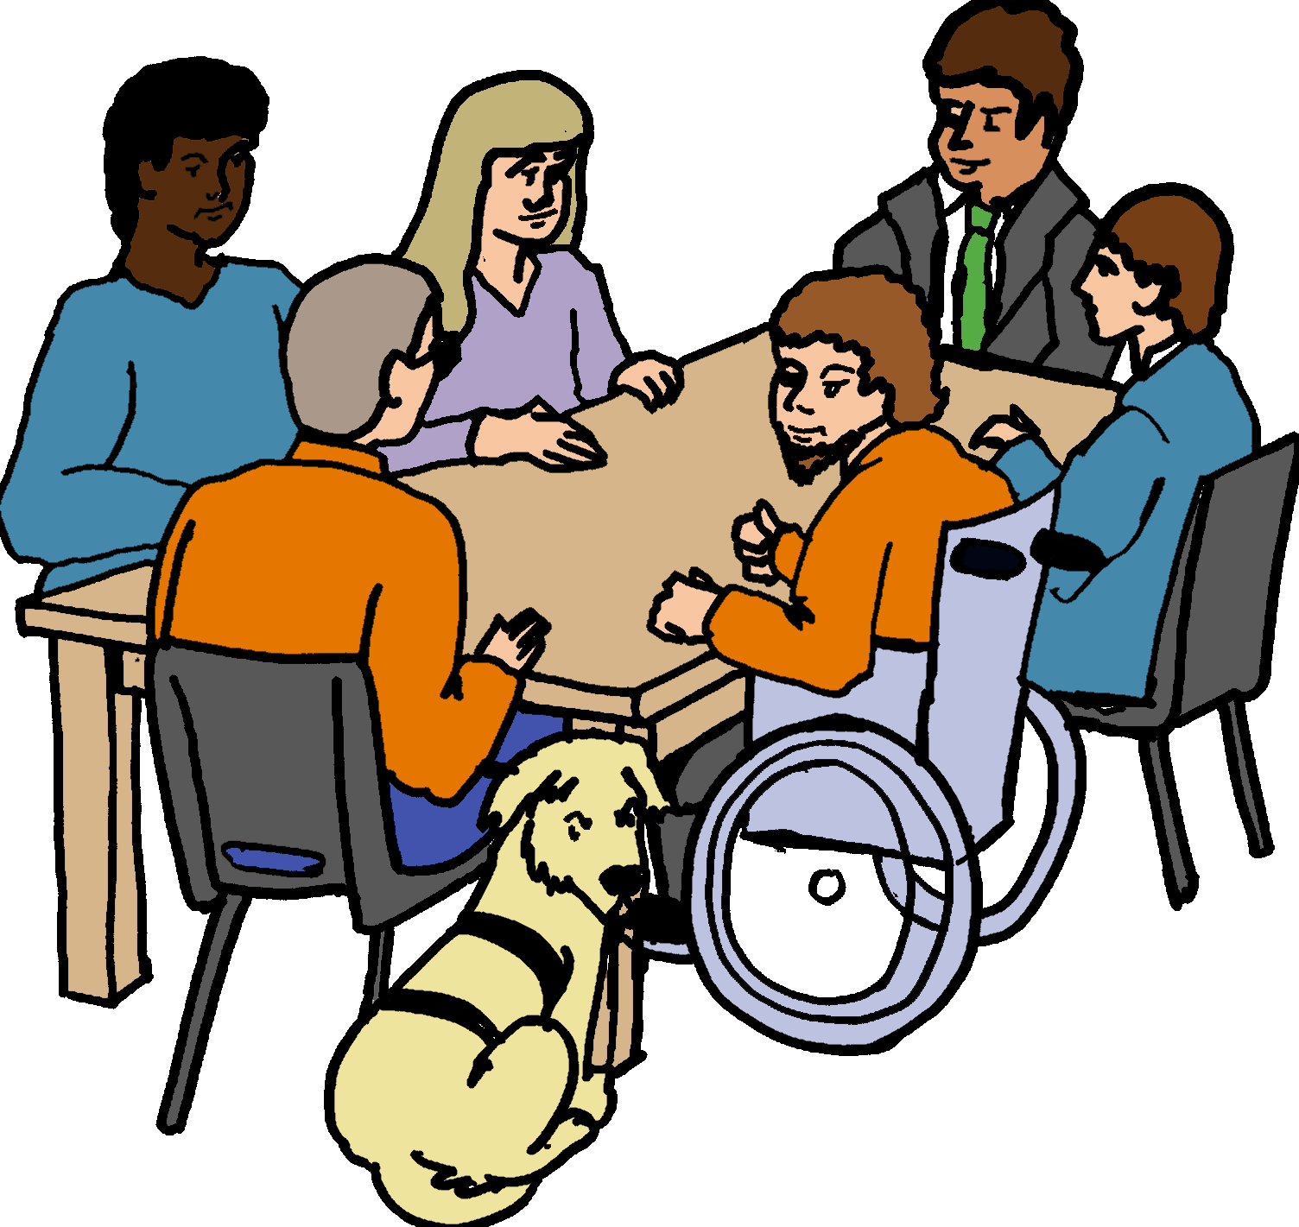

How we work together.

It is to make things better.

Our meeting. 1 May 2025.

We are the NDRP. Our long name is

National Disability Research Partnership.



We want to make things better.

It is for all people with disabilities.

We know some things are bad. Like

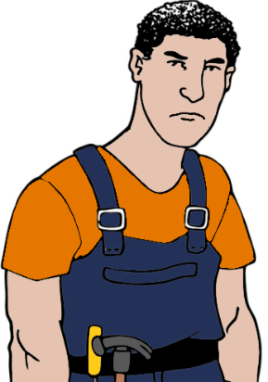

* it can be hard to get a job
* some people with a disability do **not** feel safe.

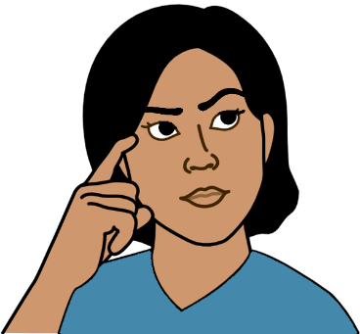We want to fix the bad things.

We need to know more about them.

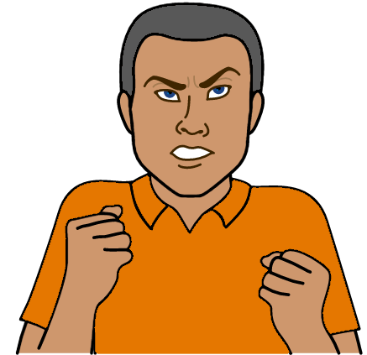We need to know

* what makes things hard
* what needs to change
* what helps you have a good life.

There are people who think about this.

They do studies. We call it research.

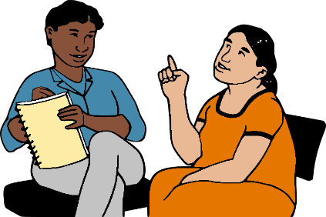They may talk to people with disabilities.

They ask you what you think.

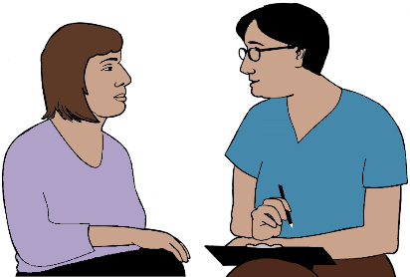

They may talk to people who

* work with you
* know a lot about disability.

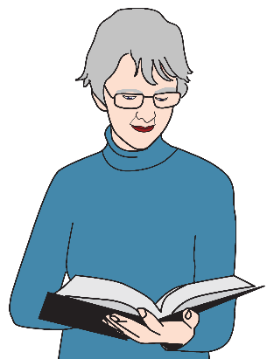

They may read lots of

* books
* papers.

**Then**

They write a report.

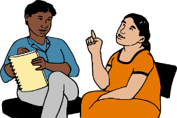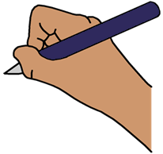

It is about what they learned.

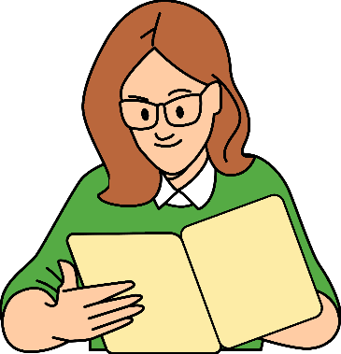Lots of people read these reports.

Like the government may read them.

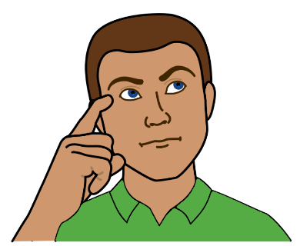

It helps them know

* what you need
* how to make things better. Like the NDIS.

We give people money.

It helps them do this work.

# Our meeting

It was on 1 May 2025.

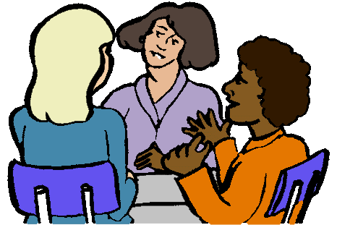People shared their ideas.

It was about how we can work together.

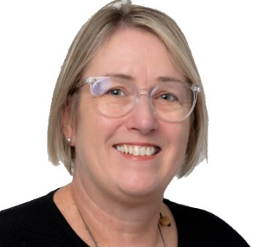Mary said hello. She is our boss.

She thanked the Aboriginal people.

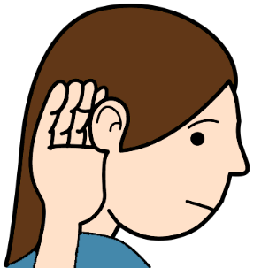

We must listen to

Aboriginal people with disabilities.

We can learn how to make things better.

# Talk 1. Erin Wilson.

She works at a uni. She is a professor.

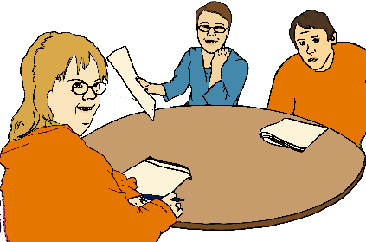

Erin talked about how to do good studies.

People with disabilities **must** be part of the work.

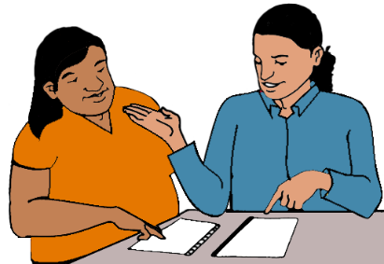You must be part of it

* at the start. You may plan the studies
* in the middle. You may tell your story
* at the end.

You may have ideas to make things better.

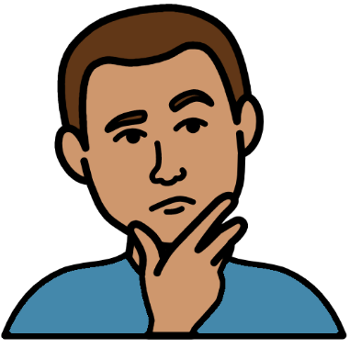A person does a study. They must think about

* how it will make things better
* how they will tell people about it.

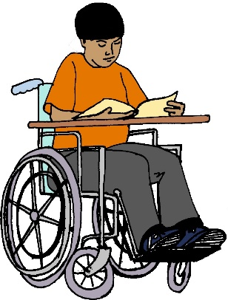Like their study may be about

* how you learn
* how to make schools better.

It is for people with disabilities.

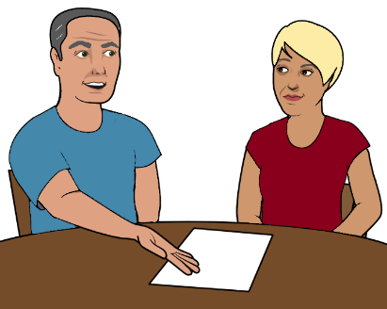They need to tell people about it. Like

* teachers
* the government
* students with disabilities
* parents.

# 

You may tell your story. It is for a study.



Your story may go in a report.

The person must tell your story in a safe way.

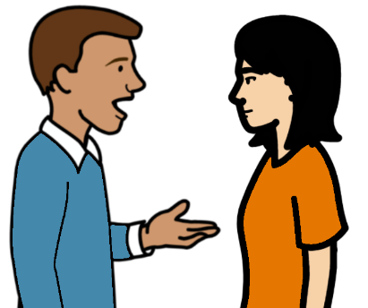

Like they

* ask you what is OK to share
* use **your** words
* check you are OK. It is after you tell your story.

# Talk 2. Lorna. Maddy. Kirsten.

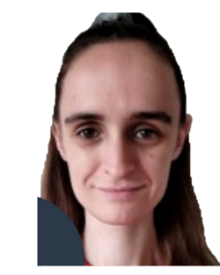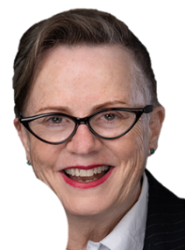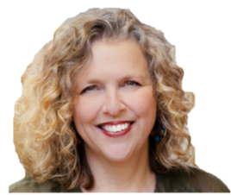

They do studies.

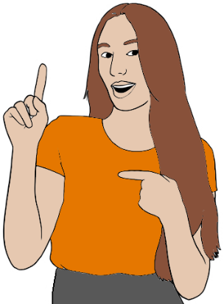

They want people with disability to be leaders.

Like you work on studies.

The studies are about what matters to you.

They wrote a report. It was a long time ago.

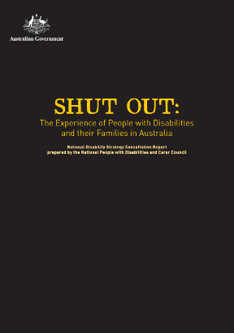

It was in 2009.

We call it the Shut Out report.

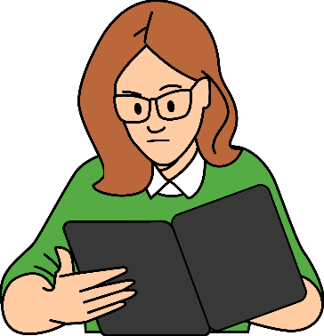The government read this report. They thought about what people with disabilities need.

**Then**

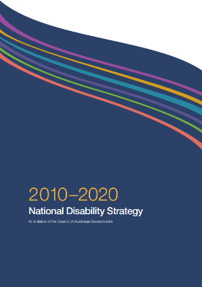

They made a disability plan. It was for Australia.

It was the first plan.

Lots of people had talked about their lives.

Their stories were in the Shut Out report.

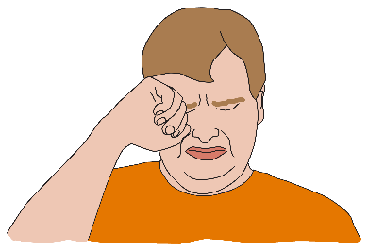Some things were hard to talk about.

Like people hurt them.

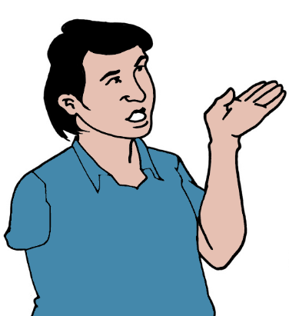We need to tell these stories. They help us know

* what are the big problems
* what needs to change.

We must tell them in a safe way. Like we

* ask you what is OK to share
* use **your** words
* check you are OK. It is after you tell your story.

# Group talks.

# We shared our ideas.

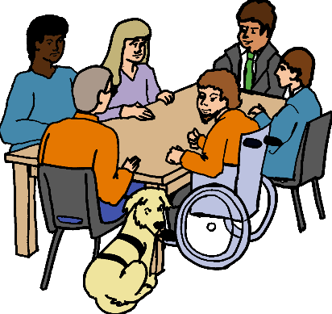We talked about how we can work together.

It is to

* do studies
* make things better.



Different people need to work together. Like

* people who do studies
* people with disabilities
* people who help you speak up.

**And**

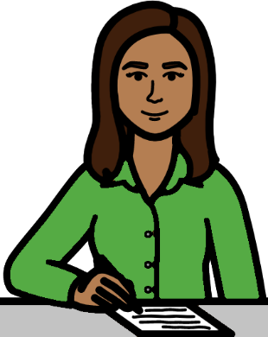More people need to work together. Like

* the government
* people who work in health
* people who work in different places.   
  Like schools.

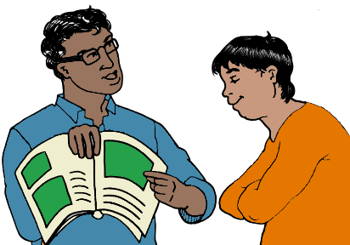

We talked about how we share our work.

Like our reports. We must

* make them easy to read
* help you know what they mean.

# 

# What you told us



You want

* to be part of the work
* to help plan the work
* to know what studies are about.

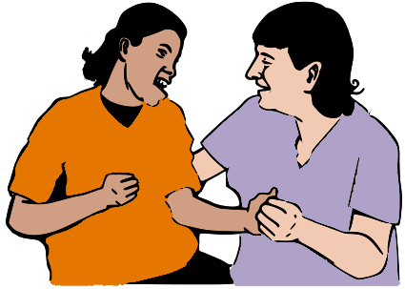You want studies to make change. It may be

* you can get more help
* people know the best way to help you
* you feel safe. Like at your job.

You work on studies with us. We need to

* listen to you
* get to know you
* show you we want to help.



People who do studies need more help. Like

* money
* training
* more people to help.

# 

# What we will do next

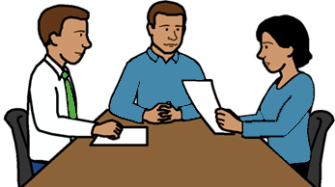

We will talk to

* people who do studies
* people who pay for studies
* the government.

We will tell them about this meeting. Like

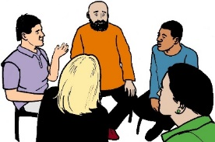

* what people said
* what we learned.

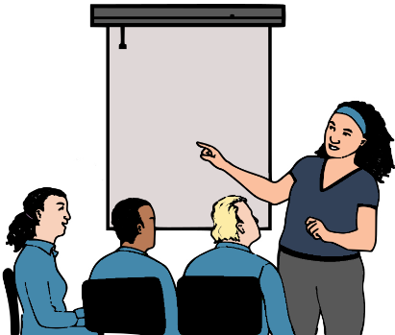We will help people who do studies. Like

* they can do our training
* we give them money to do studies.

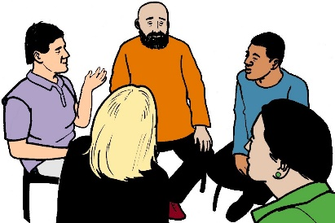We will have more meetings.

We want to learn more.

# 

# You want to know more



Call 03 9000 3813.



Email info@ndrp.org.au.

Go to www.ndrp.org.au.

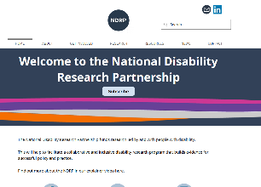

There is a video of our meeting. It has

* sign language. You may say Auslan
* words on the screen. You read what people say.

**Images**

We can use images from

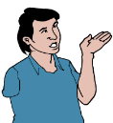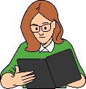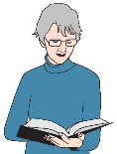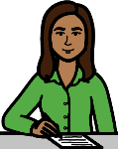

* CHANGE changepeople.org
* Freepik
* Inspired Services
* Noun Project
* Tobii Dynavox
* iStockPhotos.

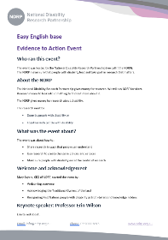This fact sheet is based on Proceedings from the National Disability Research Partnership (NDRP) Evidence to Action Event: Exploring Knowledge Mobilisation. 1 May 2025.

Access Easy English wrote the Easy English.

June 2025.